***web engineering lab # 4***

***TASK # 1***

*var n1=parseFloat(prompt('Enter First Number'));*

*var n2=parseFloat(prompt('Enter Second Number'))*

*;var op=prompt('Enter Operator + - * /');*

*if(op=='+'){var RES=n1+n2;alert(RES);}*

*else if(op=='-'){var RES=n1-n2;alert(RES);}*

*else if(op=='*'){var RES=n1*n2;alert(RES);}*

*else if(op=='/'){var RES=n1/n2;alert(RES);}*

*else{alert('INPUT INVALID!')}*

***OUTPUT:***

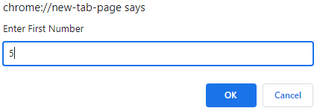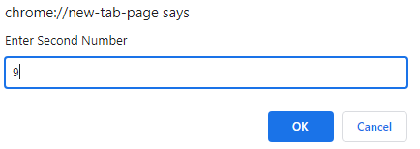

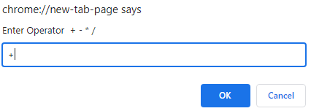 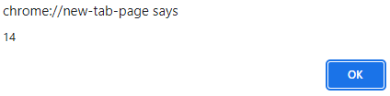

***TASK # 2***







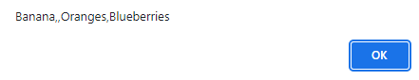



***TASK # 3:***

*var options=prompt('Alarm is Ringing!! Press S to Snooze and D to Dismiss !');*

*if(options=='S'||options=='s')*

*{while(options=='S'||options=='s')*

*{options=prompt('Alarm is Ringing!! Press S to Snooze and D to Dismiss !');}*

*alert('Wrong Input');}*

*else if(options=='D'||options=='d')*

*{alert('GOOD MORNING')}*

*else{alert('Wrong Input');}*

***OUTPUT:***

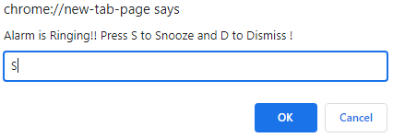 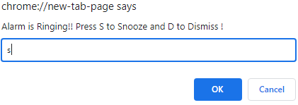 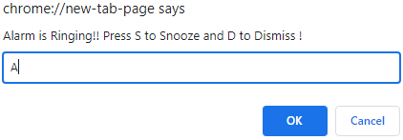 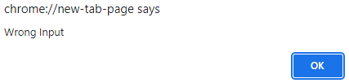 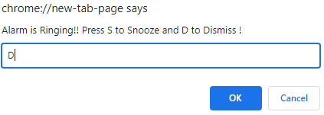 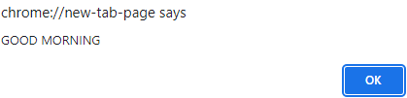

# ***Task 4:*** *Create an object and an array which we will use in our facebook exercise.*

# *Create an object that has properties "username" and "password". Fill those values in with strings.*

***var user = {***

***username : "sadia",***

***password : "zero" }***

# *Create an array which contains the object you have made above and name the array "database".*

***var database = [***

***{***

***username : "ali",***

***password : "zero" }***

***];***

# *Create an array called "newsfeed" which contains 3 objects with properties "username" and "timeline".*

***var newsfeed = [***

***{***

***username : "mehwish",***

***timeline : "zero" },***

***{***

***username : "umair",***

***timeline : "one" },***

***{***

***username : "muskan",***

***timeline : "two" }***

***]***

**\*\*\*\*\*\*\*\*\*\*\*\*\*\*\*\*\*\*\*\*\*\*\*\*\*\*\*\*\*\*\*\*\*\*\*\*\*\*\*\*\*\*\*\*\*\*\*\*\*\*\*\***

***THE END***